PHYSICAL EDUCATION LESSON #8

1st and 2nd Grade Overhand Throwing



Today we are going to practice over hand throwing. There are steps you need to follow to do it correctly. **This activity should not be done indoors. Please find an area outside if possible. You will need a small ball or stuffed animal to use to practice. Please find an open area or you can throw towards an outside wall. DO NOT THROW TOWARDS YOUR HOUSE OR ANYTHING THAT YOU CAN BREAK! You can also throw with someone if you would like!**

**STEPS FOR THE OVER -HAND THROW:**

1. **Stand sideways to target**
2. **Put your weight on your back foot. Make an uppercase L- object to ear**
3. **Step with opposite foot towards target**
4. **Twist and throw ball overhand**
5. **Follow through- throw with force!**

**Please** [**CLICK HERE**](https://youtu.be/vdAbRz62tCQ) **to watch the youtube video. It will demonstrate the proper steps for overhand throwing. Have fun and be safe!!! Please send us a message on DOJO or email us when you completed the lesson!** [**MillerA@dvsd.org**](mailto:MillerA@dvsd.org) **or** [**FeissJ@dvsd.org**](mailto:FeissJ@dvsd.org)

**Mrs. Miller& Mr. Feiss 😊**



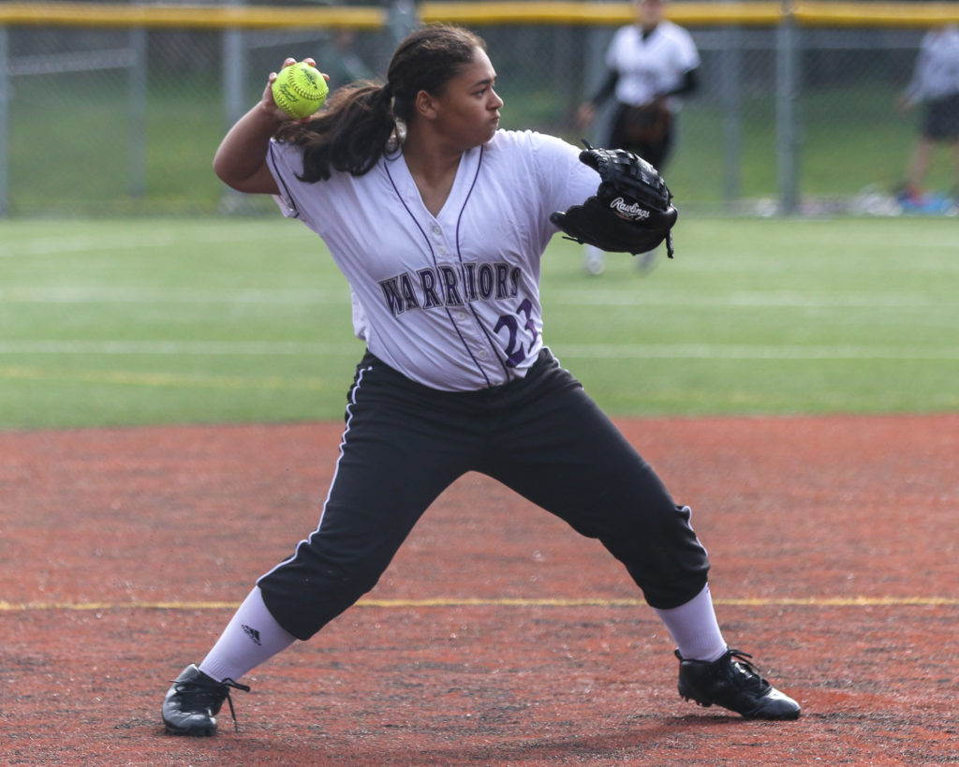

**Here is another challenge that Mr. Feiss created! Have fun with it!**

<https://photos.app.goo.gl/sKLcbNZwnrUhPe5X6>